WEATHER CLIMATE WATER |   World Meteorological Organization  EXECUTIVE COUNCIL  Seventy-Sixth Session  27 February to 3 March 2023, Geneva | EC-76/Doc. 3.1(11)
Submitted by:
President of the Services Commission
10.II.2023
DRAFT 2
[All amendments in the document have been made by the Secretariat]

AGENDA ITEM 3: IMPLEMENTATION OF CONGRESS DECISIONS: TECHNICAL MATTERS
AGENDA ITEM 3.1: Long-term goal 1: Services for societal needs

Implementation Plan for the Methodology for Cataloguing Hazardous Events (WMO-CHE) with Annexes

Summary
Document presented by: President of SERCOM, Chair of the Standing Committee on Disaster Risk Reduction on behalf of the Chair of the Expert Team on Cataloguing of Hazardous Events, in response to Resolution 12 (Cg-18) – WMO Methodology for Cataloguing Hazardous Weather, Climate, Water, and Space Weather Events and Resolution 2 (EC-73) – Implementation Plan outline for the methodology for Cataloguing hazardous events.
Strategic objective 2020–2023: Within the parameters of the Strategic and Operational Plans 2020–2023, which will further be reflected in the Strategic and Operational Plans 2024–2027.
Financial and administrative implications: Within the parameters of the Strategic and Operational Plans 2020–2023, will be reflected in the Strategic and Operational Plans 2024–2027.
Key implementers: WMO Members, Regional Associations, SERCOM in collaboration with INFCOM.
Time frame: 2023–2027
Action expected: Review the proposed Implementation Plan and its annex and adopt Resolution 3.1(11)/1 (EC-76).

GENERAL CONSIDERATIONS

Introduction
1. This document presents the draft CHE Implementation Plan in response to Resolution 12 (Cg-18) – WMO Methodology for Cataloguing Hazardous Weather, Climate, Water, and Space Weather Events, Resolution 2 (EC-73) - Implementation Plan outline for the methodology for cataloguing hazardous events, and Recommendation 5.6(3)/1 (SERCOM-2) - Implementation Plan for the Methodology for Cataloguing Hazardous Events (WMO-CHE) with annexes. The draft Implementation Plan includes a four-year demonstration project whereby WMO Members are requested to implement WMO Cataloguing of Hazardous Events (WMO-CHE) in coordination with their corresponding Regional Climate Centres (RCCs) and within two years recommendations will be made to SERCOM and the Commission for Observation, Infrastructure and Information Systems (INFCOM) on recommended changes to WMO technical regulations and/or guidelines to facilitate the national to global operationality of the WMO-CHE.
Expected action
2. Based on the above, Review the proposed Implementation Plan and its annex and adopt Resolution 3.1(11)/1 (EC-76).

DRAFT RESOLUTION

Draft Resolution 3.1(11)/1 (EC-76)

Implementation Plan for the Methodology for Cataloguing Hazardous Events (WMO-CHE) with annexes
THE EXECUTIVE COUNCIL,
Recalling Resolution 12 (Cg-18) - WMO Methodology for Cataloguing Hazardous Weather, Climate, Water and Space Weather Events,
Recalling further Recommendation 1 (EC-70) - On the approach to cataloguing high-impact event,
Recalling further Resolution 2 (EC-73) - Implementation plan outline for the methodology for cataloguing hazardous events,
Recalling further Recommendation 5.6(3)/1 (SERCOM-2) - Implementation Plan for the Methodology for Cataloguing Hazardous Events (WMO-CHE) with Annexes,
Recognizing:
(1) That the absence of globally agreed standards and procedures for identifying and cataloguing hazardous weather, climate, water, and space weather events has hampered the routine characterization and tracking of such events and associated losses and damages,
(2) That national, regional and global statistics suffer from a lack of internationally agreed definitions and accounting practices on the impacts of such events for aggregation and analysis of data losses,
(3) That, in many cases, the recorded hazardous weather, water, and climate events are not accurately associated with the recorded impact which poses challenges in reliably estimating the total losses associated with hazardous hydrometeorological events,
Convinced that the WMO-CHE, including internationally agreed definitions and accounting practices, is essential for many disasters risk management (DRM) applications,
Noting with satisfaction the progress made by the Standing Committee on Disaster Risk Reduction (SC-DRR) in cooperation with INFCOM, SC-CRM, the Hydrological Coordination Panel, the Standing Committee on Hydrology (SC-HYD), and the WMO Research Board,
Decides to endorse the Implementation Plan (IP) for the methodology for cataloguing hazardous events (WMO-CHE) as provided in the annex to the present resolution;
Requests Members to:
(1) Strengthen capabilities to implement the WMO-CHE in coordination with their corresponding WMO entities (RCCs RMSCs, WMCs, etc) [Dr. Tajbakhsh]; and
(2) Coordinate when possible, with the national disaster management agencies or other mandated national entities that record hazard impact data and information for improved disaster data and statistics;
Requests SERCOM in collaboration with INFCOM and regional associations [Mr Teshome] to:
(1) Support Member implementation;
(2) Develop an operational regional/global aggregation capacity during the first two years of the demonstration phase that leverages the WMO Global Data Processing and Forecasting System (GDPFS) and WMO Information System (WIS) for monitoring hazardous events and impacts in support of the 2030 Agenda;
(3) Ensure linkages to and collaboration with related international and regional initiatives and projects such as the United Nations Framework Convention on Climate Change (UNFCCC) Warsaw Implementation Mechanism, Sendai Agreement Monitoring tool, United Nations Economic Commission for Europe (UNECE) Task Force on Measuring Extreme Events and Disasters, UN Early Warning Initiative, Global Multi-hazard Alert System (GMAS);
(4) Facilitate and support the process of UN organizations sharing impact data and information repositories with regional associations through corresponding RCCs. [Dr. Tajbakhsh]
(5) Further develop the CHE Events List and recommended [Mr Teshome] standardized agreed-upon definitions through the appropriate WMO Constituent body process; and
(6) Report progress to the seventy-eighth session of the Executive Council (EC-78) in 2024.
Requests Regional Associations to support national and regional implementation, including ensuring appropriate coordination among RCCs in each region, such as the development of detailed operational procedures of CHE activities in the region.
Requests the Secretary-General to facilitate and support:
(1) Implementation at the national/regional [Dr. Tajbakhsh] level by leveraging good practices of Members/regional associations [Dr. Tajbakhsh];
(2) Development of linkages and a communication strategy to ensure that implementation of the CHE is well understood and supported by all stakeholders, including international organizations, research institutes and initiatives, and the insurance industry, to promote the use of the WMO-CHE and to improve the methodology in support of the 2030 Agenda;
(3) Consultation with the Intergovernmental Oceanographic Commission of UNESCO (IOC) on inclusion of tsunami into the WMO-CHE Event List and a way forward to develop a methodology for cataloguing tsunami events.

__________
Annex: 1
_______
Note: This resolution replaces [Secretariat] and Resolution 2 (EC-73) which is [Secretariat] no longer in force.

Annex to draft Resolution 3.1(11)/1 (EC-76)

WMO Cataloguing of Hazardous Weather, Climate, Water,
and Space Weather Events (WMO-CHE)

Draft Implementation Plan

This Implementation Plan (IP) includes five elements that constitute the building blocks for the WMO-CHE operational and collaboration frameworks. These building blocks include guidelines for event recording methodology and processes, tailored guidelines for specific regional needs, operational aspects, changes to WMO Regulations and guidance products, partnerships with Disaster Risk Reduction (DRR) stakeholders, loss and damage communities, and the private sector.

Introduction
The international community has been working for decades to standardize hazard and impacts information to understand better risks and how they change over time at the national, regional, and global levels. Impacts are typically recorded by the national disaster management agency (or other mandated agency) in terms of mortality and morbidity, loss of, and damage to, physical assets, and associated economic damages and losses. Attribution is then made to the associated hazard in consultation with national services that have the mandate for documenting the hazard, such as the National Meteorological and Hydrological Services (NMHS). NMHSs and other relevant national scientific and technical agencies have an opportunity to catalogue hazardous events in order to provide authoritative information on each hazard event and associated larger-scale phenomena.
Implementation of the WMO Cataloguing Hazardous Weather, Climate, Water, and Space Weather Events (WMO-CHE) will provide the foundation for strengthening understanding of hazards, their impacts (and their changes over time) with scalability to the larger physical processes. The CHE is not intended to be a real-time database but a scientific (climate) record of hazardous events.
When implemented, the WMO-CHE methodology (approved by WMO Resolution 12 (Cg-18)), will provide an authoritative data source of the magnitudes, durations, locations, timing, and frequency of hazardous events. By implementing the WMO-CHE, WMO Members will enable new possibilities for the development of impact-based warnings, risk analysis based on empirical hazardous event data, research, and more systematic and scalable hazard and impact data, which could benefit Members and other stakeholders in the loss and damage community.
The purpose of this Implementation Plan is to provide information on what needs to be put in place in terms of guidelines, infrastructure, procedures, and capacity that will help to operationalize the WMO-CHE. Partnering with Disaster Risk Reduction (DRR) institutions and the private sector is crucial to realizing WMO-CHE's full benefits; therefore, this IP includes mechanisms to leverage this collaboration. Finally, information on human and financial resources and guidance on these resource requirements to implement the WMO-CHE are also part of this IP.

Enabling characteristics
WMO-CHE informs planning, climate change adaptation, and disaster risk reduction through:
(1) Strengthening capabilities of hydrometeorological institutions NMHSs, the Regional Specialized Meteorological Centres (RSMCs), RCCs, and other relevant operational organizations [Dr. Tajbakhsh] to serve stakeholders in impacts accounting by providing them with an authoritative, scientifically reviewed, and quality assured scalable data set of hazardous events that enables easy association between each hazardous event and its impacts such that the resulting combined data can be aggregated globally; and
(2) Enhancing collaboration between and among the agencies responsible for managing information on hazards (operational data collection, research, and applications) and the stakeholders involved in adaptation, DRM, civil protection, risk transfer, and humanitarian activities.

Benefits and Goals
Benefits include improved:
• Tracking of indicators relevant to international policy frameworks such as the Sustainable Development Goals (SDGs), Paris Agreement, and Sendai Framework;
• Risk identification (hazard component, empirical methodology of understanding hazards, how hazards interact with other hazards and their combined impacts, e.g. hazard clusters);
• Risk reduction and adaptation (empirical methodology for ongoing quantification of events as input to developing building standards, land use planning, strengthening Multi-Hazard Early Warning Systems (MHEWS), and disaster reduction planning);
• Risk transfer (insurance, risk facilities, catastrophe bonds);
• Tracking of event characteristics (including complex and cascading events) trends in frequency, severity, and temporal and spatial distribution; and,
• Identification of causal contributions of hazards, exposure, and vulnerability to impacts.
The goals of the cataloguing methodology include strengthening:
• Members’ capabilities to record weather, climate, water, and space weather events in a systematic and standardized way;
• WMO's contribution to the monitoring of the 2030 [Mr Graham] global agenda through an empirical science-based approach;
• Members’ disaster management capacities and MHEWS through improved risk-based information, Impact-Based Forecasts, and climate watch advisories;
• Members' capacity to quantify the value of their service and provide evidence for requesting sustainable funding;
• Members’ capacities to better understand the hazards that affect their country/territory, how the hazards interact with other hazards (compound and cascading hazards), and their combined impacts;
• WMO leadership related to hydrometeorological and climate-related hazards through the provision of a WMO approved list of event types associated with hazard impacts; and,
• Partnerships with the stakeholders of the impacts and loss and damage community for the sharing of hazard event information and linkage thereof to impacts data and information.

WMO-CHE Implementation Timeline
The WMO-CHE will be implemented nationally over a four-year period through a series of regional kick-off meetings as well as national training (remote and in-person). Regional implementation will include two phases including a regional/global demonstration phase for two years then upon successful implementation experience transitioning to the WMO-CHE operational phase (Figure 1). The purpose of the regional/global demonstration phase is to test the GDPFS/WIS capabilities in relation to the WMO-CHE and to provide specific recommendations for updates/changes to the Manual on GDPFS, WIS manual, and other relevant WMO regulatory and guidance materials to Congress 20 for consideration.
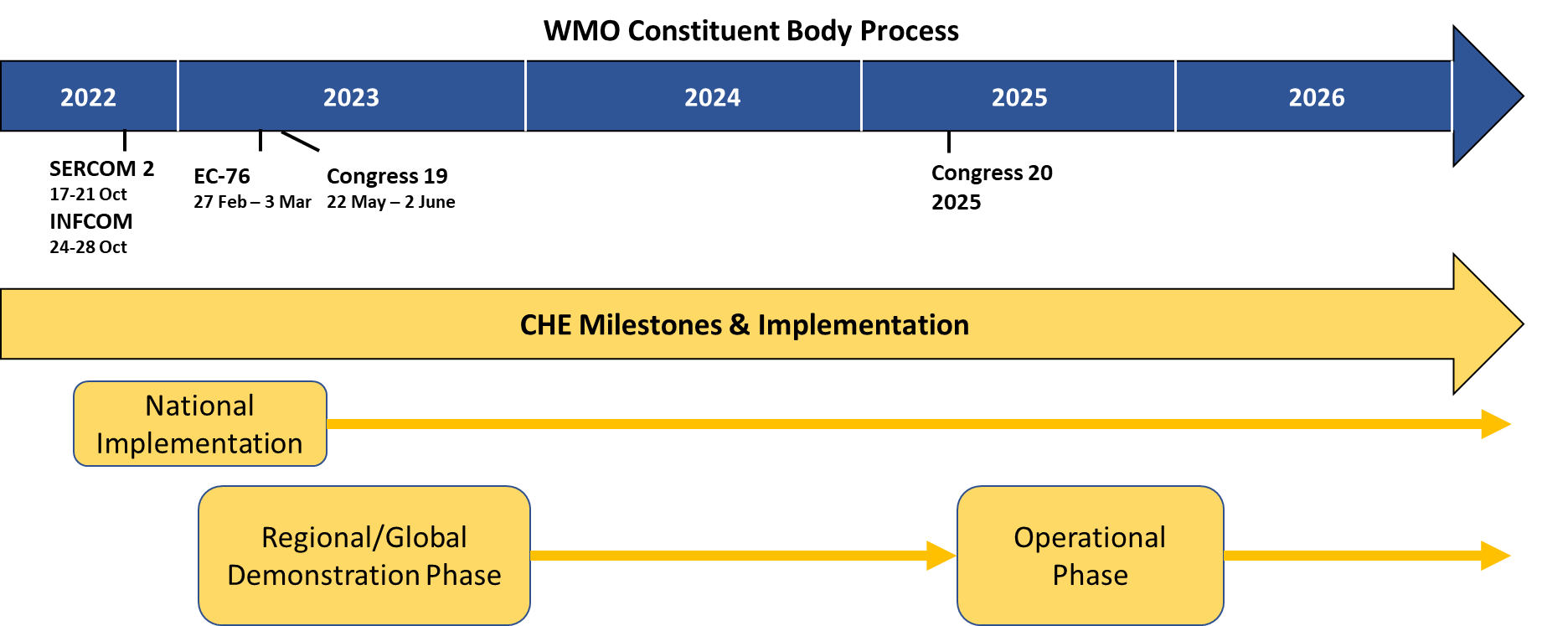
Figure 1: Key milestones for CHE implementation
1. WMO guidelines on the methodology and processes for event recording
The WMO-CHE Implementation Guidelines found in Annex 1 provide the basis for the implementation of the CHE at the national to regional levels. The guidelines provide the context, methodology, and operational procedures, and provide general guidance on the resources required for implementation. The procedures are developed in consideration of existing practices, depending on the event types relevant for each country/territory and region.
2. Refinement and expansion of Event Types
Resolution 12 (Cg-18) provided an initial list of hazardous event types, with the expectation that it would be a living list subject to further refinement based on implementation experience. During the development of this Implementation Plan, WMO has identified a number of hazardous event types under WMO auspices and as well that fall under the mandate of other organizations which can be of use in recording cascading, simultaneous, [Dr. Tajbakhsh] and complex hazardous events. WMO Members are encouraged to use only those event types that are related to hazardous events experienced within their country/territory. The WMO-CHE Event List is included as Annex 2 of this Implementation Plan.
For WMO Member information and use in the WMO-CHE event recording process, the event names are also included in the information document (INF.). The information document lists the event (hazard) names, approved definitions by a WMO constituent body process, synonyms, and additional descriptions, as well as examples of drivers, outcomes, and risk management practices or processes providing more concrete information on the contexts and possible impacts of the hazard. The information document will be reviewed by the WMO constituent body process and upon approval will be included as Annex 2 to this plan and updated on a regular basis.

3. Development of tailored guidelines for specific regional needs
During the WMO-CHE demonstration phase, WMO regional associations, through relevant working groups, in collaboration with WMO technical commissions and the Secretariat, will develop tailored guidelines for the regions' specific needs. These include the possibility to extend or limit the events list, and additional specific requirements for data collection, management, and exchange based on their regional infrastructure (RCCs, RSMCs, others). The WMO regional associations will provide guidance and quality assurance (of linkages and regional data continuity from the NMHSs).
4. Update of existing or development of new regulations for data collection and information management
Regulations on operational procedures governing data collection and information management on hazardous events will leverage the existing WMO infrastructure of the GDPFS codes and practices and WIS. During the demonstration phase, recommendations for updates to WMO regulatory and guidance material will be developed. These would include CHE-specific requirements in terms of standards/guidance for data collection and exchange between national and regional levels globally.
5. Collaboration framework with DRR, loss and damage communities and the private sector

UNDRR-WMO Centre of [Dr. Tajbakhsh] Excellence for Disaster and Climate Resilience (CoE)
The CoE is a joint initiative of the World Meteorological Organization (WMO) and the United Nations Office for Disaster Risk Reduction (UNDRR). It will bring together relevant representatives of the United Nations system, international financial institutions, the private sector, academia and science, and other partners. The CoE aims to improve comprehensive disaster and climate risk management by working across disciplines and institutions to develop products, services, and processes to guide science, policy, and practice to accelerate the achievement of the Sendai Framework, the Paris Agreement, and the 2030 Agenda for Sustainable Development.
The WMO-CHE is included as one of its deliverables where UNDRR and WMO will work to include the CHE methodology and process into its Sendai monitoring tool and the new version of DesInventar. Pivotal in this regard is the WMO-CHE Events list as it will provide the basis for Monitoring the Sendai Framework Agreement.

Partnership with the private sector
Partnership with the private sector aims to identify technological opportunities and solutions for real-time identification and assessment of hazardous events and their impacts, such as disruptive technologies and big data.
Existing international and regional conferences and working arrangements such as those under the auspices of the International Telecommunication Union (ITU), the World Summit for Information Society (WSIS), and others will be used for engaging in partnerships with the private sector on WMO-CHE.
6. Guidance on resource requirements
Funding and capacity requirements for implementation and maintenance of the CHE:

National and Regional Implementation
(a) Operational and coordination processes;
(b) Augmentation of staff job competencies;
(c) Staff and operational costs;
(d) Infrastructure costs (e.g. information technology such as database and corresponding website development and management).

International collaboration and coordination
(a) The second workshop on CHE with stakeholders involved in the collection and archiving of data on hazardous event impacts
(b) Further development of the Implementation Plan through a Demonstration Phase.
7. Implementation training and outreach
During the demonstration phase the following training activities are planned:
• Regional kick-off training meetings for both NMHSs, and RCCs in collaboration with RTCs
• National meetings for training & stakeholders – leverage other projects such as Severe Weather Forecasting Programme (SWFP)
• Online video training sessions for countries/territories/groups of countries/territories
• Online training materials (pamphlets & video training modules)

________________

Annexes: 2

Annex 1
Guidance for Implementation

WMO CATALOGUING of HAZARDOUS WEATHER, CLIMATE, WATER, AND SPACE WEATHER Events (WMO-CHE)

Table of Content

Introduction 12
Components of Implementation 13
- WMO-CHE Methodology – A Common standard 13
- Event types (hazards) 15
- Procedural aspects 15
- Event Detection 15
- Event parameters 16
- Post-event analysis 17
- Quality Control 18
- Optional impact information 18
- Institutional aspects 19
- National Meteorological and Hydrological Services (NMHSs) 19
- Regional Climate Centres (RCCs) 20
- WMO-CHE operational system 20
- Institutions involved in impacts assessment and documentation 21
- Infrastructural aspects 21
- Human resources 21

Introduction
The international community has been working for decades to standardize hazard and impacts information to understand better risks and how they change over time at the national, regional, and global levels. Impacts are typically recorded by the national disaster management agency (or other mandated agency) in terms of mortality and morbidity, loss of, and damage to, physical assets, and economic damages and losses. Ongoing cataloguing of hazardous events by national services that have the mandate for observing and documenting hazards, such as National Meteorological and Hydrological Services, enables the data on impacts to be authoritatively linked to the specific hazardous event with which they are associated.
Implementation of the WMO Cataloguing Hazardous Weather, Climate, Water, and Space Weather Events (WMO-CHE) will provide the foundation for strengthening understanding of hazards, their impacts (and their changes over time) with scalability to the larger physical processes. The CHE is not intended to be a real-time database but rather a scientific (climatological) record of hazardous events and their characteristics, including magnitudes, locations, duration, and timing.
The CHE methodology, approved by the Eighteenth World Meteorological Congress (Resolution 12 (Cg-18)), provides the basis for NMHSs to better serve stakeholders in impacts accounting by systematically recording and cataloguing hazardous events as part of the NMHS observing and monitoring function of the Earth's atmosphere, weather, climate, water, and space weather events. This methodology ensures that each event is recorded uniquely with a standardized event name, begin and end times, spatial area, and the capability to link events to larger-scale phenomena (e.g. heavy rain, strong winds, storm surge flooding, and landslides to a tropical cyclone) and characteristics (e.g. severity). The linking feature makes this methodology scalable from local (micro event) to larger phenomena, including on climate timescales. The methodology encourages NMHSs to partner with their corresponding statistical or disaster management agencies to systematically link hazardous event data with data on the associated impacts.
This implementation guide provides WMO Members with guidance for WMO-CHE implementation.
Key definitions
Hazard: A process, phenomenon or human activity that may cause loss of life, injury or other health impacts, property damage, social and economic disruption or environmental degradation.
Hazardous Event: The manifestation of a hazard in a particular place during a particular period of time. Annotation: Severe hazardous events can lead to a disaster as a result of the combination of hazard occurrence and other risk factors.
Disaster: A serious disruption of the functioning of a community or a society at any scale due to hazardous events interacting with conditions of exposure, vulnerability and capacity, leading to one or more of the following: human, material, economic and environmental losses and impacts.
Source: UNDRR open-ended intergovernmental expert working group on indicators and terminology. https://www.undrr.org/terminology

Components of Implementation

(1) WMO-CHE Methodology - A Common Standard
The methodology uses modern hierarchy-free database methods (no tree structure to store data) and facilitates flexible analysis. The methodology relies on storing data uniquely with metadata that enables hierarchies (vertical and horizontal hierarchies) at all scales to be created dynamically. The WMO-CHE focuses centres on authoritatively identifying and recording hazardous weather, climate, water, space weather events ('event'), and other related environmental phenomena (such as air quality). The methodology employs a parameter to link related smaller events to the larger-scale phenomena, reducing event duplication risk.
The methodology involves recording a hazardous event uniquely by assigning a random Universal Unique Identifier (UUID) number as the event identifier. Appended to the UUID are several attributes (metadata) which comprise the event record (or data record) (see Figure 1 below and Table 1).

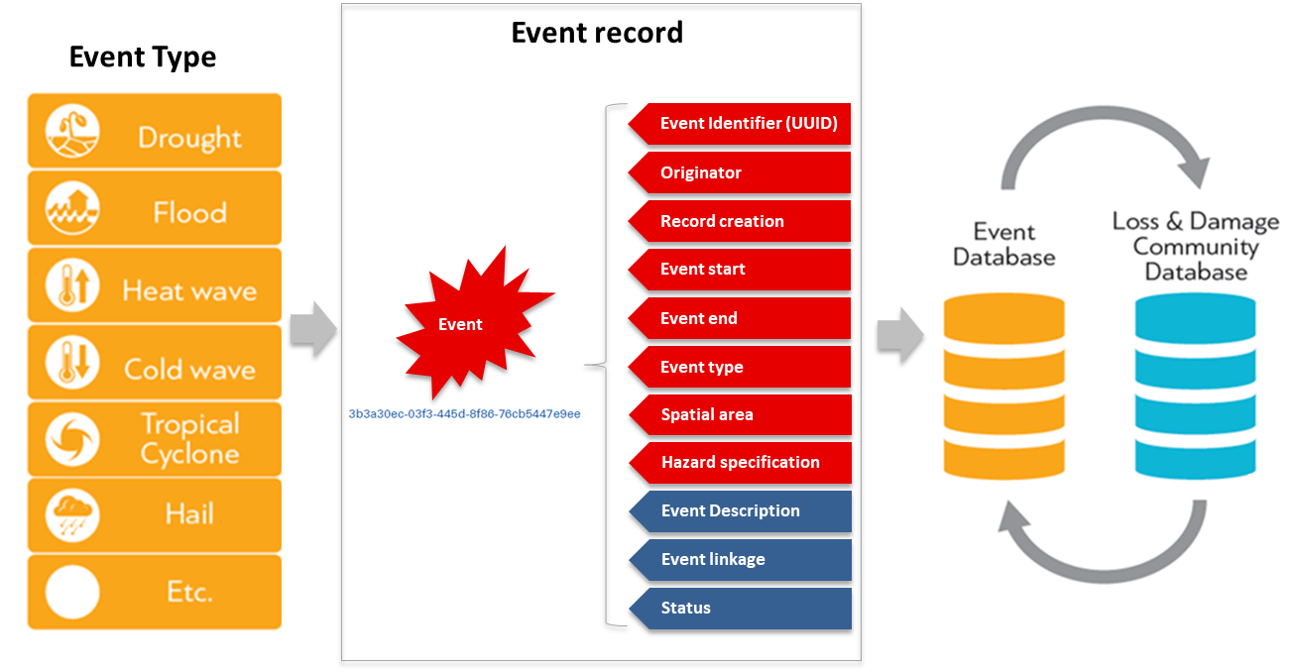
Figure 1: Event record containing the Event Identifier (UUID) and key event attributes (attributes in red are mandatory entries)

Table 1: Event Attributes (Attributes with a * are mandatory for recording)
Attribute | Format | Description | Comments
Event Identifier* | Alphanumeric number | UUID (32 character random sequence)  Example:  9c921a78–9578–4aeb-b85e-806d257d6ca0 | The format of the random number can be generated at this URL:  https://www.uuidgenerator.net/
Originator* | Text | Name of the institution that is recording the event | List of authorities designated by WMO Members.
Record Creation* | Date/Timestamp | Date- and timestamp of the event record | Date format is DD.MM.YYYY. Timestamp is optional. When used, it is in 24-hour format, UTC (e.g. 1320).
Event start* | Date/Timestamp | The time when the event started | Date format is DD.MM.YYYY. Timestamp is optional. When used, it is in 24-hour format, UTC (e.g. 1320).
Event end* | Date/Timestamp | The time when the event ended | Date format is DD.MM.YYYY. Timestamp is optional. When used, it is in 24-hour format, UTC (e.g. 1320).
Event Type* | Text | Controlled WMO standard list (Annex 2 to this document)
Spatial area* | Recognized spatial datatype, i.e. GIS-ready files or political boundary area. | Spatial area of the hazard event in a recognized spatial format (point, line, or area) | When recording the spatial area using multiple geopolitical areas (e.g. a province or state), each geopolitical area is to be separated by a comma. Names of geopolitical areas require authoritative linked GIS-ready files.
Hazard specification* | Text | Controlled national hazard list | This hazard list is to be controlled by the WMO Member. It is intended to be a list of hazards defined by the WMO Member and consistent with the national early warning system terminology.
Event Description | Text | Description of the event such as max temp, highest wind speed, severity, local event name e.g. Typhoon Yolanda (Haiyan), and other information that can assist in linking data on associated impacts | The description is not to include associated impacts.  Use of coding from the WMO Manual on Codes (WMO- No. 306) and the technical regulations Volume I (WMO-No. 49) is encouraged.
Event linkage | Alphanumeric number string | UUID of the event with which this event is associated
Status | Text | Ongoing / Completed/ Validated | Indicate the status of the record
Optional attributes
Impact | Text | General description of any impacts associated with this event. | Impact information is supplemental and indicative and is not to be considered authoritative information.
Affected sectors | Text | Specifies the sectors that may have been affected.

(a) Event types (hazards)
The WMO Event Types List contains a standard list of hazardous event types (Annex 2). The list is intended to be a living list that can be amended through the appropriate WMO governance mechanism with inputs from WMO Members, WMO regional associations, and collaborating institutions having a mandate on other hazards. The Event list is to be used to facilitate the standardization of event names. Recognizing that each WMO Member has different event types they experience, each Member is to use only the Event names that are useful for the recording of the hazardous events that affect their country/territory.
The sections that follow describe the procedural, institutional, infrastructural and human resource requirements and processes for event cataloguing.

(2) Procedural aspects
Procedures for data collection and information management include event detection, parameter recording, post-event analysis, quality control, and making such data available at national and global scales.
After the event onset, the UUID, and related parameters, including the Event Identifier, Originator, Record Creation, Event start, and Event Type, are to be recorded. The Event end, spatial area, description, and UUIDs of related events are all entered at or before the time of record closure. The event record is to be quality-controlled on the accuracy, linkages, and format before setting the status parameter to be completed.

(a) Event detection
Hazardous events can be identified through different methodologies:
• Verified occurrence of the event
• Direct observation such as wind measurement, hailstorm, flooding, etc.
• Post-event information such as news broadcasts or news articles, validated by observational data
The chosen event type (Annex 2) is the one that most accurately describes the meteorological, climate, hydrological, or space weather event. All hazardous events should be recorded when they are considered significant, for example, when: (1) a national or regional threshold criterion is exceeded, (2) there are associated impacts, or (3) the event is newsworthy.
An event should be recorded as a single event if there is an obvious hazardous system present – such as in the case of an event leading to a continuous, or nearly continuous, swath of hazardous conditions. The single event would be described as occurring from Point A to Point B with the corresponding event begin and end times. The event description can describe the width and length of the event’s impact footprint.
At the national level, Members are responsible for developing a list of potential hazards including a standardized list of hazards which the NMHS issues warnings/alerts thereby linking to the national early warning system. This standardized list is to be used for the CHE hazard specification parameter. When developing this list, WMO Members are encouraged to utilize the hazard naming contained within the United Nations Office for Disaster Risk Reduction (UNDRR)-International Science Council (ISC) Hazard definition and classification review (Technical Report) 2020 and the UNDRR-ISC Hazard Information Profiles (HIPs) to facilitate standardization at the regional and global levels.
At the WMO regional level, RCCs are to record larger-scale events that may affect multiple countries/territories. As these larger-scale events may spawn multiple smaller-scale events of different types, linkages among these related events need to be coordinated at national and regional levels to facilitate the analysis of appropriate linkages through post-event analysis. These types of linkages will facilitate the analysis of cascading and complex events.

(b) Event parameters
When an event is identified, the following parameters are to be completed:
Unique identifier (UUID): The UUID can be generated online, or a script on a computer can be developed. There are many online tools that can generate the random UUID, such as https://www.uuidgenerator.net/ (Bulk Version 4 UUID Generation). At the national level, regional UUIDs should be used when impacts are expected or have occurred from a regional hazard (e.g. tropical cyclone).
Originator: The entity and country/territory that is the originator of the record is to be entered here (e.g. national weather service, hydrologic service, regional centre).
Event start & Event end: The event’s beginning, and end dates and times should be recorded as accurately as possible. Specifying times to the nearest minute will be difficult in certain situations. To minimize this problem, the observer should carefully compare all event reports and information (e.g. radar data, observations) to ensure that event times are recorded accurately. The event description should be consistent with the event start and end times.
Event type: The selected Event Type from Annex 2 is the one that most accurately describes the hazardous event. The Event Type list is a controlled list that enables aggregation at the regional/global levels.
Spatial area: The spatial area of the event is to be recorded and finalized before the record closing. The spatial area can be recorded as GIS coordinates or by areas based on defined boundaries (e.g. political or physical) that are defined by GIS coordinates (point, line, or polygon). The entire event area is to be recorded (using a cluster approach) before the event record is closed. Event spatial area should be determined based on the spatial extent of the hydrometeorological phenomena and hydro-meteorologically contiguous phenomena (that is, not the spatial extent of associated impacts) and should not be sub-divided into multiple events based on political-administrative boundaries.
Hazard specification: Select the hazard from this nationally controlled list that most accurately describes the hazardous event within the national early warning system terminology.
Description: The description of the event documents the magnitude or severity of the event using, when available, the standard metrics developed for each specific event type. These can include measurements of maximum temperature, highest wind speed, drought index value, Saffir-Simpson category, etc. The description should also include unique details about the event (temperature, precipitation, return period, etc.). Only the more significant values should be summarized, such as monthly, seasonal, or yearly records. For example, a new monthly single-storm precipitation record or a new, all-time rainfall record value can be included in a flood event.
Event Linkage: The Event Linkage parameter must be filled out before record closing. The purpose of the Event Linkage parameter is to allow a subsidiary event to be linked to a higher-order event (see Figure 2). As explained previously, each event is to be recorded individually and assigned its own UUID. When it has been established that an event has been generated as a consequence of a higher-order event, the UUID of the higher-order event is entered into the event’s Event Linkage attribute. In the example in Figure 2, the Event Linkage from the flooding event is the UUID of the heavy rain event. The heavy rain Event Linkage is the tropical cyclone event UUID. The tropical cyclone event does not have an event linkage because it is the highest order event from which all other events in the Figure were generated. All events in the group can be found by searching for each UUID, and Event Linkage encountered until all events in the group have been identified.

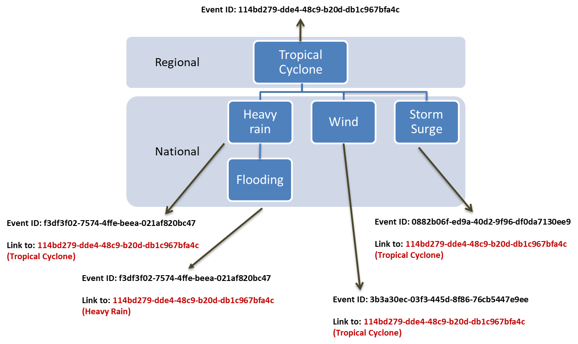
Figure 2: Example of linking events
Status: The event record status is to be filled out based on the completeness of the record. The options are:
1. Ongoing: The record requires more information to be completed. A typical example is slow-onset events such as drought or events requiring further refinement of begin/end times, identification of the spatial area, etc.
2. Completed: the record is completed but has not been quality assured and validated
3. Validated: The record is complete, including post-event analysis and quality control.

(c) Post-event analysis
Review the event record, review of linkages, and include additional information if available in the description. The analysis is to be conducted to ensure the following:
• Elimination of duplicate event records. When duplicate events are identified, then select the event record that is the most complete and includes any information from the other duplicate records that is missing, then delete the other duplicate records.
• Event start and Event end dates are the best science-based estimate.
• Event type reflects the hazard associated with actual or potential impacts of the event. This will ensure, for example, that impacts associated with a hailstorm are linked to a hail event and not to a thunderstorm.
• Event Linkages from related hazardous events are included in the Event linkage parameter with specific attention to include any related regional or other WMO Members' event UUIDs in appropriate cascading relationships to allow all impacts associated with the group of linked events to be aggregated.
• Event Record reflects the environmental conditions that precipitated the hazardous event as accurately as possible.

(d) Quality Control
Quality control is to be performed at all levels, including national, regional, and global, to ensure the record represents the best information available at the time of record closing. This includes but is not limited to the following:
1. All mandatory attributes are complete and accurate;
2. The Spatial area reflects the event area and is encoded correctly; and,
3. The Event Linkage parameter results in linkages to all related events in a group (e.g. storm surge linked to the associated tropical cyclone) with peer review verification.

(e) Optional impact information
Impact information usually is not the mandate of NMHSs but rather is the responsibility of other agencies within a country/territory (e.g. the National Disaster Management Authority). One of the key CHE enablers includes enhancing collaboration between and among the agencies responsible for recording hazard impact information, such as the disaster management or national statistical agency. This collaboration (institutional partnership) is to provide the relevant impact assessment and recording authority with an authoritative record of hazardous events to which the impacts can be linked using a common event UUID.
Impact information (optional) can be entered into the description of the event (see Table 1), but it is not considered authoritative. Instead, it can aid national agencies that record impact information in assigning the impact information to the correct event UUID.
All hazardous events related to each other can be identified using their UUIDs and Event Linkage parameters. This allows impacts data associated with these events to be similarly aggregated. It is beneficial, therefore, if the authority responsible for documenting event impacts records those impacts using the UUID of the specific event with which the impacts are associated. In the example in Figure 2, if the authority responsible for recording impacts records wind damage using the UUID of the wind event and flood damage using the UUID of the flood event, these impacts can be aggregated subsequently to obtain a complete inventory of all damage associated with the tropical cyclone. Assigning the impacts to each particular event with which they are associated allows the impacts data to be used for assessing exposure, vulnerability, and risks more accurately later.

(3) Institutional aspects
The methodology described above guides organizations responsible for collecting and archiving data for hazards under their mandate to develop and operationalize their national hazardous events catalogue. Operational procedures governing data collection and information management on hazardous events depend on national needs, resources, and capacities, including:
• Development of standards/guidance for data collection and exchange at the national level and between national and regional levels
• Data sharing agreements and protocols between relevant hydro-met and impacts-related authorities where appropriate for linking event and impacts data
• Procedures to be developed (and tested) for each WMO Region and, where applicable, sub-regions
• Coordination of operational activities at national, regional, and global levels
Institutional roles at national, regional, and global scales would include:

(a) National Meteorological and Hydrological Services (NMHSs)
NMHSs are typically a primarily responsible entity at the national level for detecting, monitoring, and managing information on hazardous events linked to weather and climate by leveraging their meteorological observing and monitoring capabilities. Other agencies manage special networks for collecting data on specific hazards. Examples include hydrological services collecting flood data, agriculture agencies collecting hail pad data, or specialized agencies collecting data on space weather hazards. In such cases where responsibilities are so distributed, the NMHS may play a coordinating role and undertake data collection itself on the events under its mandate.
The NMHS is responsible for developing their national operational hazardous event recording processes for the hazards, including types of hazardous events amongst the event types list as shown in Annex 2 and criteria/definition of “significant” hazardous event to be recorded under their mandate and for ensuring systematic and quality-controlled event records are stored efficiently (Figure 3).
NMHSs functions within the CHE system include:
• Identification and recording of hazardous events;
• Quality control of event records;
• Cataloguing of event records;
• Aggregation, clustering of national-scale events through post-event analysis;
• Coordination with other national specialized agencies (e.g. hydrological, marine, geological, health, agriculture, environment) to record relevant events within their mandates;
• Coordination with Regional Climate Centres, particularly on linkages across events affecting multiple countries/territories.

(b) Regional Climate Centres (RCCs)
RCC functions include:
• Monitoring and identifying events mandated by RCCs, Regional Specialized Meteorological Centres (RSMCs), and other specialized centres at the regional level and issuance of an event record and publishing thereof;
• Cataloguing of regional-scale event records;
• Ensuring appropriate event linkages (e.g. reducing duplication);
• Aggregation, clustering, and post-event analysis;
• Linkages of national events to regional/global events; and,
• Quality control coordination with NMHSs and with other regional entities (e.g. RSMCs).

(c) WMO-CHE operational system
As a first step toward the development of the WMO-CHE operational system, priorities shall be put on capacity development activities of Members who need technical support to operationalize hazardous event recording. A regional system leveraging the WMO RCCs will be put into place to identify and record hazardous events at the regional level (Figure 3). The operational system will leverage WIS and WIS 2.0 for data discovery and retrieval.
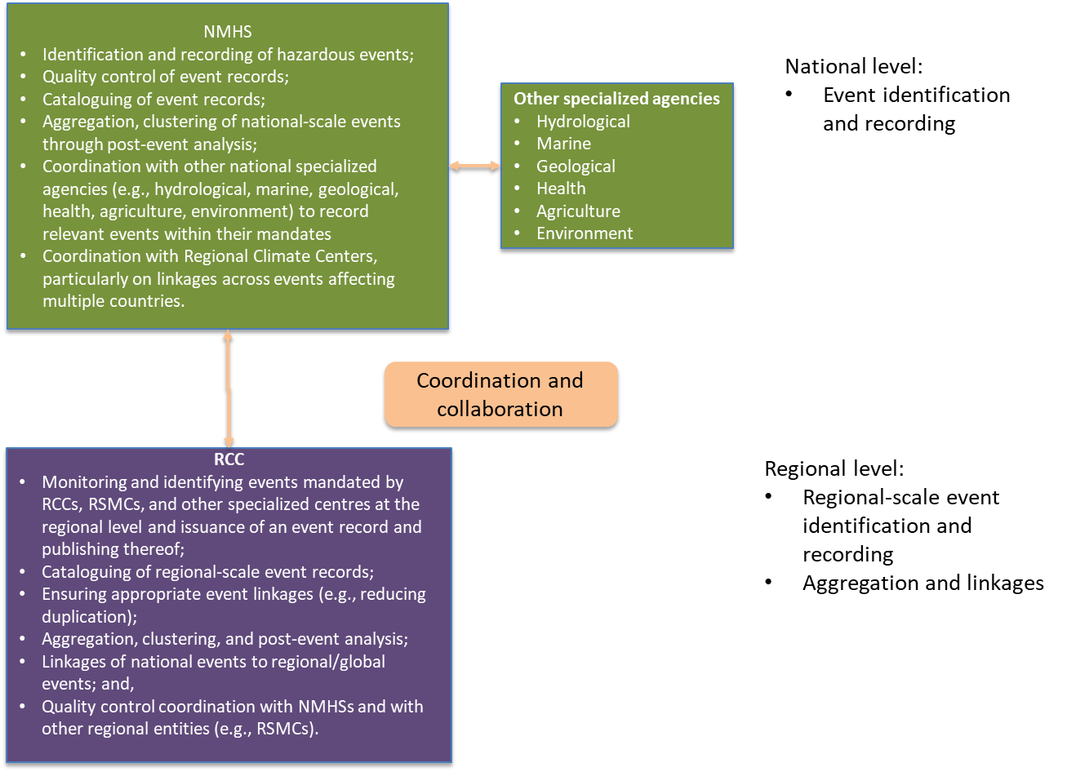
Figure 3: Schematic of WMO-CHE operational system

(d) Institutions involved in impacts assessment and documentation
The full value of the WMO-CHE is realized when data on events is linked to data on impacts using the event UUID as the common reference. This entails an institutional partnership between the NMHS or other authorities mandated to collect event data and counterpart institutions mandated to assess and document associated impacts, as explained previously. Operationalization of this collaboration involves the same aspects as in the WMO-CHE, namely procedural, institutional, infrastructural, and human resources. NMHSs and WMO regional centres are encouraged to be proactive in reaching out to their counterparts mandated to collect and document impact data to ensure that the necessary collaboration in all four of these areas is fully implemented.

(4) Infrastructural aspects
In the most basic form, Member countries/territories can record hazardous events in a simple spreadsheet containing the event’s attributes on a standard computer.
More advanced implementation of the WMO-CHE be made in the form of a dedicated database (e.g. MySQL, PostgreSQL, which are open-source, or other more advanced proprietary database systems) with data entry standardization. These types of databases can be augmented with product developments such as analysis of events, derivation of statistics, or visualization purposes. For quality assurance, toolbox scripts containing quality control procedures can be made by using open-source languages with database processing capabilities (e.g. R or Phyton).
A more advanced system operating at the regional level (i.e. WMO RCCs) with integrated processing capabilities from online submission of national and regional event reporting, quality assurance checks, and product development is desirable when capabilities and resources are available. To aid standardized data input, WMO will explore the possibility of creating a single-entry system that allows all events to be entered through a common interface during the WMO-CHE demonstration phase.

(5) Human resources
Hazardous event recording needs to be designed and developed based on national needs in consideration of various aspects, including hazard and disaster characteristics, hazard monitoring capacity, expertise, and resources available. This requires human resources and training activities for record creation and maintenance, event linking and checking, quality control, hazard data exchange with cooperating centres, liaising with impacts data centres, and report preparation.
Resource requirements that Members have experienced during the WMO-CHE trial phase and identified by Members with similar systems are estimated at one full day of work per month. The time required depends on the human resources and the number and severity of hazardous events to be recorded.
_______________

Annex 2

WMO Methodology for Cataloguing Hazardous Weather, Climate, Water, and Space Weather Events

  - Event Types List

Introduction
The WMO Event Types List contains a standard list of event types that can be potentially associated with hazardous events. The list is intended to be a living list that can be amended through the appropriate WMO governance mechanism with inputs from WMO Members, WMO regional associations as well as collaborating institutions having a mandate on other hazards. The events list will facilitate the standardization of event terminology across various domains of applications. Event definitions can be referred to in the WMO relevant technical regulations. A catalogue of these event names with their corresponding definitions will be developed and made available to Members by Q1 of 2023.

List of events

Avalanche  Cold wave  Drought/Dry spell  Dust storm/Sandstorm  Extra-tropical cyclone  Flood  Fog  Forest fire  Freezing rain  Frost  Hail  Haze/Smoke  Heatwave  High Seas/Rogue waves etc.  High UV radiation  Icing  Landslide/Mudslide & Debris flow | Lightning  Pollen pollution/Polluted air  Rain/Wet Spell  Snow  Snowstorm  Space weather event  Storm surge/Coastal flood  Thunderstorms/Squall lines  Tornado  Tropical cyclone  Tsunami  Volcanic ash  Wildland fire  Wind
__________

Annex Resolution 12 (Cg-18)
The UUID is an International Organization for Standardization (ISO) standard random number which can be generated by a designated national, regional or global authority. There are many online tools that can generate the random UUID such as https://www.uuidgenerator.net/ (Bulk Version 4 UUID Generation).

